**PART B**

## *Write an HTML program to draw line, polyline and rectangle and fill rectangle with red color using svg tag*

<html>

<body>

<svg height="210" width="500">

<line x1="0" y1="0" x2="200" y2="200" style="stroke:rgb(255,0,0);strokewidth:2" /> Sorry, your browser does not support inline SVG.

</svg>

<svg height="180" width="500">

<polyline points="0,40 40,40 40,80 80,80 80,120 120,120 120,160"

style="fill:white;stroke:red;stroke-width:4" /> Sorry, your browser does not support inline SVG.

</svg>

<svg width="400" height="110">

<rect width="300" height="100" style="fill:rgb(255,0,0);stroke-width:3;" /> Sorry, your browser does not support inline SVG.

</svg>

</body>

</html>

**Output:**

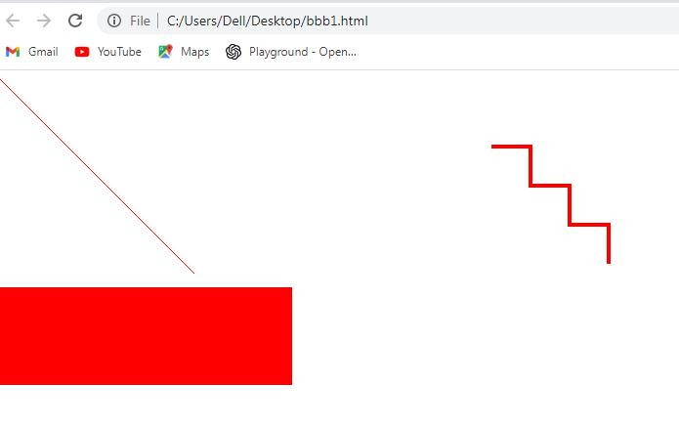

## Write an HTML program to draw star and multiple circle and with different color using svg tag

<html>

<body>

<svg width="400" height="200">

<circle cx="100" cy="100" r="50" fill="red" />

<circle cx="200" cy="100" r="50" fill="blue" />

<circle cx="300" cy="100" r="50" fill="green" />

</svg>

<svg id = "svgelem" height = "200" xmlns = "<http://www.w3.org/2000/svg>">

<polygon points = "100,10 40,180 190,60 10,60 160,180" fill = "red"/>

</svg>

</body>

</html>

**Output:**

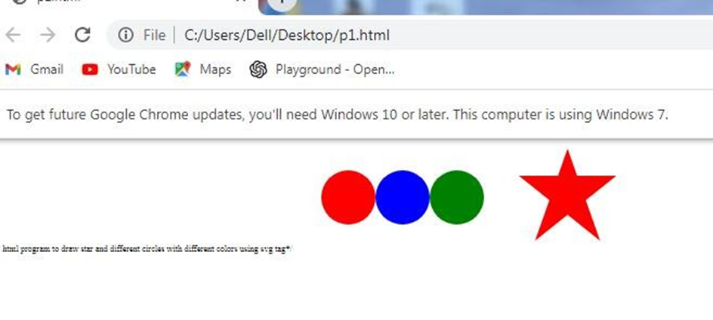

2B.Write an HTML program to create logo with linear gradient properties using svg tag.

<html>

<body>

<svg height="500" width="700">

<defs>

<linearGradient id="grad1" x1="0%" y1="0%" x2="100%" y2="0%">

<stop offset="0%"

style="stop-color:rgb(255,255,0);stop-opacity:1" />

<stop offset="100%"

style="stop-color:rgb(255,0,0);stop-opacity:1" />

</linearGradient>

</defs>

<ellipse cx="100" cy="70" rx="85" ry="55" fill="url(#grad1)" />

<text fill="#ffffff" font-size="45" font-family="Verdana" x="50" y="86">MIT</text>

</svg>

</body>

</html>

**Output:**

## Write an HTML program to draw square and rectangle using canvas tag and javascript

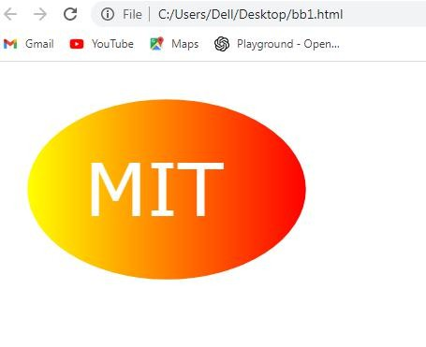

**//Rectangle//**

<html>

<body>

<h1>Rectangle</h1>

<canvas id="myCanvas">Your browser does not support the canvas tag.</canvas>

<script>

var c = document.getElementById("myCanvas"); var ctx = c.getContext("2d");

ctx.fillStyle = "#FF0000"; ctx.fillRect(0, 0, 180, 80);

</script>

</body>

</html>

**Output**

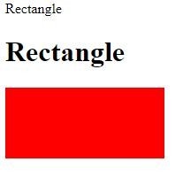

**// Square//**

<html>

<body>

<h1>The Square canvas element</h1>

<canvas id="myCanvas" onmouseover="c()">Your browser does not support the canvas tag.</canvas>

<script>

var c = document.getElementById("myCanvas"); var ctx = c.getContext("2d");

ctx.fillStyle ="#FF3456"; ctx.fillRect(0, 0, 80, 80);

</script>

</body>

</html>

**Output**

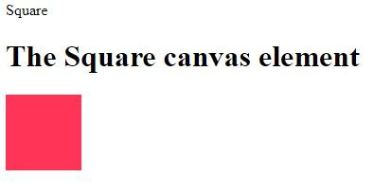

1. **Write an HTML program to draw bezier curve using canvas tag and JavaScript**

<!DOCTYPE html>

<html>

<head>

<script type="text/javascript"> function draw() {

var canvas = document.getElementById('canvas');

if (canvas.getContext) {

var ctx = canvas.getContext('2d');

}

ctx.beginPath(); ctx.moveTo(20, 20);

ctx.bezierCurveTo(20, 100, 200, 100, 200, 20); ctx.stroke();

}

</script>

</head>

<body onload="draw();">

<canvas id="canvas" width="220" height="220"></canvas>

</body>

</html>

**Output:**

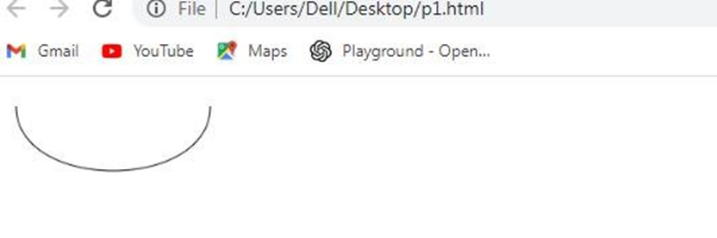

1. **Write an HTML program to import an external image into a canvas and then to draw on that image.**

<html>

<head>

<title>Draw on Image</title>

<style>

canvas {

border: 1px solid black;

}

</style>

</head>

<body>

<h2>Draw on Image</h2>

<canvas id="canvas"></canvas>

<script>

const canvas = document.getElementById('canvas');

const ctx = canvas.getContext('2d');

let isDrawing = false;

let startX, startY;

const image = new Image();

image.src = 'https://via.placeholder.com/400'; // Replace with the URL of your image

image.onload = function() {

canvas.width = image.width;

canvas.height = image.height;

ctx.drawImage(image, 0, 0);

};

canvas.addEventListener('mousedown', (e) => {

isDrawing = true;

startX = e.offsetX;

startY = e.offsetY;

});

canvas.addEventListener('mousemove', (e) => {

if (!isDrawing) return;

const x = e.offsetX;

const y = e.offsetY;

ctx.beginPath();

ctx.moveTo(startX, startY);

ctx.lineTo(x, y);

ctx.stroke();

startX = x;

startY = y;

});

canvas.addEventListener('mouseup', () => isDrawing = false);

</script>

</body>

</html>

**Output:**

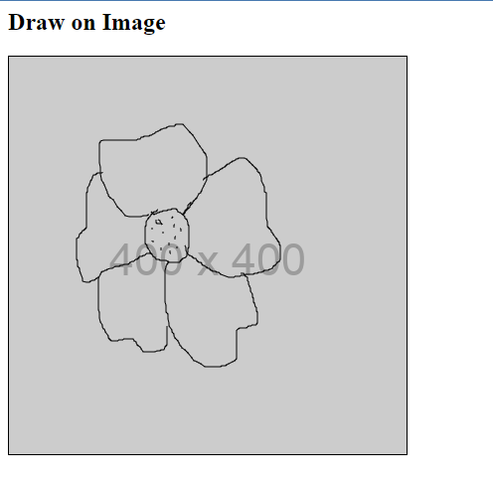

## Write an html program to draw rectangle box using canvas and change background to red and change scale of rectangle to 2 on hover properties.

<!DOCTYPE html>

<html>

<head>

<script>

function drawRectangle()

{

var c = document.getElementById("myCanvas"); var ctx = c.getContext("2d");

ctx.fillStyle = "black"; ctx.fillRect(20,20,150,100); c.addEventListener('mouseover',onMouseOver);

}

function onMouseOver(){

var c = document.getElementById("myCanvas");

var ctx = c.getContext("2d"); ctx.fillStyle = "red"; ctx.fillRect(20,20,300,200);

}

</script>

</head>

<body onload="drawRectangle()">

<canvas id="myCanvas" width="300" height="300">

</canvas>

</body>

</html>

**Output:**

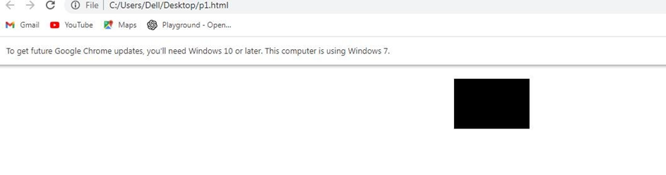

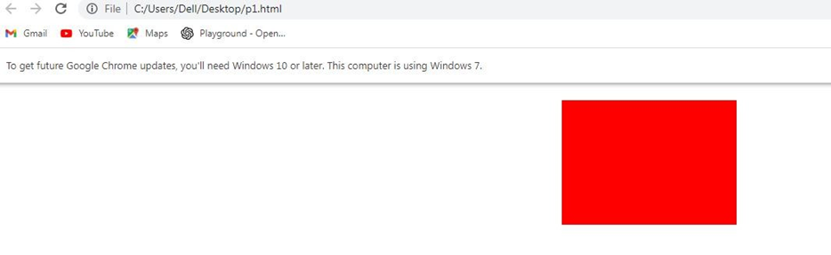

## Write an html program to draw a circle using canvas and to apply the rotations animations on loading the page

<!DOCTYPE html>

<html lang="en" xmlns="<http://www.w3.org/1999/xhtml>">

<head>

<meta content="text/html; charset=ISO-8859-1" http-equiv="content-type">

<script type="application/javascript"> var centreX = 100; var centreY = 100; var radius = 75;

var rotateAngle = 36 * Math.PI / 180; var startAngle = 0 * Math.PI / 180; var endAngle = 36 * Math.PI / 180; var counter = 0;

var animFlag;

var colours = ["teal", "red", "green", "blue", "yellow", "violet", "orange", "grey", "navy blue", "purple"];

function init() {

var canvas = document.getElementById("canvas"); if (canvas.getContext) {

var ctx = canvas.getContext("2d"); ctx.lineWidth = 3.0;

ctx.fillStyle = "orange"; ctx.fillRect(200, 100, 75, 20); ctx.fillStyle = "black"; ctx.font = "15px verdana";

ctx.fillText("Rotate", 215, 114); drawWheel();

}

}

function drawWheel() {

var canvas = document.getElementById("canvas"); if (canvas.getContext) {

var ctx = canvas.getContext("2d"); for (i = 0; i < 10; i++) {

ctx.fillStyle = colours[i]; ctx.translate(centreX, centreY); ctx.rotate(rotateAngle); ctx.translate(-centreX, -centreY); ctx.beginPath(); ctx.moveTo(centreX, centreY);

ctx.lineTo(centreX + radius, centreY);

ctx.arc(centreX, centreY, radius, startAngle, endAngle, false); ctx.closePath();

ctx.fill();

}

}

}

function rotateWheel(rnd) {

var canvas = document.getElementById("canvas"); if (canvas.getContext) {

var ctx = canvas.getContext("2d"); ctx.translate(centreX, centreY); ctx.rotate(rotateAngle); ctx.translate(-centreX, -centreY); drawWheel();

counter++;

if (counter > rnd) { counter = 0; clearInterval(animFlag);

}

}

}

function mouseClick() {

var rnd = Math.ceil(Math.random() * 100);

animFlag = setInterval(function () { rotateWheel(rnd) }, 25);

}

window.addEventListener("load", mouseClick, false);

</script>

<title>Animation - Moving Banner</title>

</head>

<body onload="init();">

<canvas id="canvas" width="600" height="500"></canvas>

<br>

</body>

</html>

**Output:**

